Introduction

Hypotheses that deal with psi phenomena are often relevant to psychology as well. For instance, theory and research in social psychology may look differently if it is acknowledged that people may also have telepathic means of assessing the thoughts and motives of others. Also, assuming that people may have some conscious or unconscious knowledge about future events is relevant when trying to model the decision making process, or when trying to understand how people acquire new knowledge or new skills. This paper will report a study that looks into physiological aspects of choosing while learning a new task. Both psi and psychological research questions are being explored in one experimental design.
In psychology, physiological processes are hypothesized to be involved in learning processes and decision making. One influential view (see e.g., Damasio, 1996) assumes that the consequences of our decisions elicit emotional (and thus physiological) responses, which are automatically linked to features of the decision situation, and stored in memory. When encountering a similar decision situation, features of the decision situation will unconsciously trigger these physiological memories, dubbed 'somatic markers', which will in turn unconsciously bias our decisions away from risky choices. Somatic markers are assumed to be especially present and relevant during the so-called pre-conceptual phase, while people have no conscious knowledge yet about the riskyness of choices.
Experimental studies supported this reasoning (e.g., Bechara, Damasio, & Damasio, 1997). Researchers used an implicit learning task (Iowa Gambling Task, IGT). With the IGT, participants drew cards with monetary wins or losses from four different decks, only two of which are advantageous in the long run, and were asked what they thought the game was about after each ten draws. Skin conductance, a physiological measure that is associated with arousal, was measured during the entire task. It was found that before participants indicated conscious knowledge about which of the decks were advantageous, their choices improved. They showed preferences for the good decks, and their skin conductance increased right before drawing cards from the bad decks. The increased skin conductance was interpreted as a somatic marker, unconsciously warning participants about a risky choice, and presumably generally biasing their choices away from the bad decks.
Although at face value the theory sounds plausible and has found experimental support (using the IGT), it has been criticized extensively as well. For instance, it was argued that knowledge about the decks was not unconscious at all, only difficult to put into words, as was shown by a deeper probing of what people really felt about the decks (Maia & McClelland, 2004). Other researchers have shown that increased skin conductance could be attributed not to the long-term value of a deck, but to its comparatively higher losses and wins (Tomb, Hauser, Deldin, & Caramazza, 2002). They reversed the task so that now the good decks had comparatively higher losses and wins, and even though participants learned to picked more cards from the decks that were advantageous in the long run, there was a reversal of the original skin conductance data, supporting their argument: skin conductance was now higher prior to draws from the good decks. Still, because of its inherent plausibility, and because most of the studies have used only the IGT and skin conductance (Dunn, Dalgliesh, & Lawrence, 2006), it is worth the effort to explore the somatic marker hypothesis using different implicit learning tasks and different physiological measures.
Not only the somatic marker hypothesis predicts changes in physiological processes during decision making. Other studies found that changes in physiological processes appear to be an inherent part of the process of choosing. In a task where participants saw four numbers in a row, after which they had to pick one, pupil dilation was largest while looking at the number they would later select (Einhäuser, Koch, & Carter, 2010). Similarly, heartrate was relatively increased while participants looked at the stimulus (out of two) that they would later choose (Lobach & Bierman, 2007; Lobach, 2010). For lack of an established name for this phenomenon, we call the physiological changes accompanying the choosing 'somatic choice'.
In parapsychology, physiological processes have been shown to be correlated with future events that cannot be predicted in any known way. For instance, so called 'presentiment' studies have shown time and again that right before an emotional stimulus is presented to a completely passive participant, skin conductance level is relatively increased, as compared to right before neutral stimuli (e.g., Bierman & Radin, 1997; for a review, see Lobach, 2008). Later it was shown by others that these correlations with future events held up in choice situations as well (Tressoldi, Martinelli, Massaccesi, & Sartori, 2005). Participants saw four pictures, presented sequentially, after which all four were presented simultaneously, and they had to select the one they guessed the computer would pick as the target picture. Although participants' conscious choices were at chance level, heartrate was elevated while looking at the picture that would later turn out be the target picture (Tressoldi et al. 2005). We subsume both types of physiological psi-effects under the term 'somatic psi'.
For the present study we developed an implicit learning task, presenting it as a game with the goal to increase the total score. In each trial, a door is presented on the computer screen. The participant can choose to open the door, or skip to the next one. If the door is opened it will slide open and reveal a win or a loss that will be added to the total score. There are three different doors, a positive, negative and neutral door, each with different probabilities of wins and losses. Heartrate is measured continuously throughout the task.
Based on the somatic marker hypothesis we expected that in the course of this task, when learning occurs, a decreased heartrate would serve as a warning signal. Unlike the Iowa Gambling Task, the design of this task will allow us to establish with somewhat more certainty whether any physiological differences are actually associated with the positive and negative stimuli themselves, as would be predicted by the somatic marker hypothesis. In addition, we would be able to establish whether a decreased heartbeat predicted the participants choice to open or skip a door. If so, this would support the notion that a decreased heartbeat serves as a warning signal, biasing the choices away from the risky ones.
Based on the somatic choice effects found in earlier experiments, we expected that heartrate would be increased when participants choose to open a door, relative to when they decide to skip a door.
Based on previously reported somatic psi effects, we expected heartrate to decelerate more strongly prior to discovering a loss behind a door than prior to discovering a win.
For exploratory reasons we included an intuition questionnaire (Human Information Processing scale, HIP), developed by Taggart and Valenzi (Taggart & Valenzi, 1990).

Method
Participants
There were 50 participants, most of them friends and fellow students of the five sophomore student experimenters. One participant was excluded from the data-analysis due to unusable heartrate data. Analyses were thus done over 49 participants (9 male, 41 female, mean age= 23.57 , sd=7.3)

Materials
Computer door game. Each trial in the computer door game starts with a blank screen for two seconds. Then one door, randomly selected out of three different doors, is presented. After one second, the mouse becomes available and the participant has to decide within two seconds whether to open the door by clicking on it, or to skip to the next door by clicking the big on screen 'button' underneath the door that says 'Skip to next door'. If the participant clicks the door, it slides open slowly, taking a second to reveal a win or a loss, which will then stay on screen for another second (Fig. 1). Wins and losses can be +50, +100, -50 or -100. A pleasant sound goes with a win, an unpleasant sound goes with a loss. If the participant clicks on 'Skip to next door', a neutral sound is played, button and text change color, stay on screen for another second, after which the next trial starts.

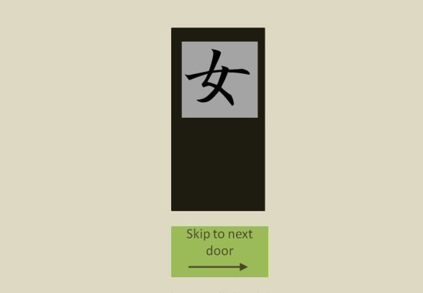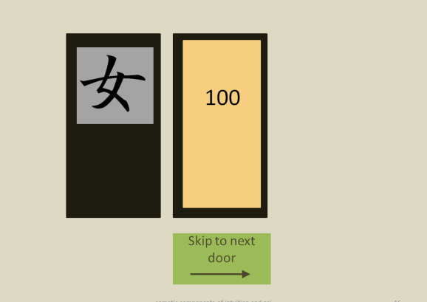
(a) (b)
Fig. 1 The screen showing the door, (a) before opening the door, and (b) after the participant opened the door, in this case revealing a win of +100.

Participants may skip as many doors as they wish, but after 75 opened doors the game is over. This means that not all participants have the same total number of trials, but it ensures that all participants have the same amount of feedback.
There are three different doors, each with their own Chinese character (Fig. 2). For the duration of the game, each character is consistently associated with either a 70/30, 30/70 or 50/50 probability of a win/loss. Characters and probabilities are counterbalanced across participants; at the start of the game the program determines randomly how characters and probabilities are coupled. As soon as the participant clicks on the door, win or loss is randomly determined (taking the weighted probabilities into account), with a 50/50 probability of being big (+100 or -100) or small (+50 or -50). Late responses produce a message on screen to remind participants to choose within two seconds, and 10 is subtracted from their total score.



Fig. 2 Three different doors, each with a different Chinese character. For the duration of one game, each door is consistently associated with different probabilities of win and loss.

At the start of the Door Game, participants are informed that the objective of the game is to increase their score by opening doors. It is suggested that they should go by their feelings, and they are encouraged to open the doors that feel good, and to decide quickly because a late response would decrease their score with 10. They are not told about the different probabilities, nor that the game ends after 75 doors are opened. Instead they are told that the game ends after approximately 15 minutes.
The program then starts with three practice trials, using blank doors, and all showing a win of +10.

Heartrate measurement and data processing. Heartrate was measured with 512 samples/s using four Biosemi active electrodes and a Biosemi Active AD-Box with Actiview software. Two electrodes were attached to the earlobes, a third was placed directly left of the chest bone, and the fourth on the right side, directly under the lower rib. To synchornize participants' behavior in the Door Game and heartrate, Actiview software registers markers sent online from the Door Game experiment, indicating start of trial, type of door, choices by the participants, and type of win or loss.
For later analyses, R-peaks of the heartsignal were identified and marked using Brain Vision Analyzer software (BVA..). The intervals between R-peaks are interbeat intervals (IBIs). Outliers (IBIs > 1.5 sd of the mean) were removed, and IBIs were normalized, dividing each IBI by the average IBI for that participant, in order to correct for individual differences in heartrate. Then IBIs were interpolated, to allow for the fact that stimulus onset did not coincide with heartbeats. Depending on the analysis, IBIs were averaged separately for all relevant conditions (more details in the Results section).

HIP Questionnaire. The Human Information Processing Questionnaire (Taggart & Valenzi, 1990) consists of 30 items, distributed over 3 Intuition and 3 Ratio scales of 5 items each. Participants indicate the applicability to themselves on a scale from 0 (not applicable at all) to 6 (completely applicable) in a computerized version of the questionnaire. An example of an Intuition statement is: “I like to find new and better ways of doing things”.

Procedure
At the beginning of the session, participants received general information about the procedure, after which they signed a consent form.
They were escorted to the adjacent room, seated in front of the computer, where they were connected with the heartrate equipment. The experimenter made sure that the participant was comfortable and the heart signal was correctly saved. The Door Game was started, which lasted for approximately 15-20 minutes, followed by the HIP questionnaire on the computer, taking about 10 minutes. At the end of the session, participants returned to the first room, and were interviewed about their experiences during the task and their ideas about the different doors. After their spontaneous answers to the open questions, they were informed that the three different characters were associated with different probabilities of wins and losses, and were asked to identify the positive, negative and neutral characters. The whole procedure took about 40 minutes.

Results

Somatic marker hypothesis

Improved performance. The somatic marker hypothesis assumes that physiological differences between positive and negative choices improve performance, even before people have conscious knowledge about the value of the choices. A required condition for somatic markers would thus be that performance improves during the course of the task. To test this, we divided the 75 opened doors in 3 blocks of 25 trials each, and determined for each of these blocks the percentage of each door type (positive, negative or neutral) that was opened in that block. The percentages of opened negative and positive doors in the 3 blocks were subjected to a 3 (blocks) * 2 (door type: positive or negative) repeated measures ANOVA, indicating a significant divergence between the percentages of opened positive and negative doors and an increased performance during the course of the task, F(2,96) = 8.13, p = .001.
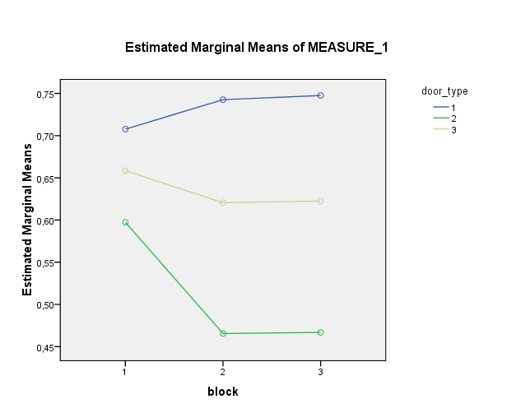
Fig 3: Percentages of opened positive and negative doors for each of the 5 blocks. Each block consists of 15 opened doors and a varying number of skipped doors.

The neutral doors were not included in this analysis, as they were not supposed to show any change across the 5 blocks. As expected, the percentages of opened neutral doors fell consistently between the negative and positive doors for each of the 3 blocks (Fig 3).

Conscious knowledge. At the end of the session, participants were interviewed about their thoughts about the three doors. Unfortunately, results of most exit-interviews did not allow us to gain an accurate assessment of the spontaneously ventured ideas about the three different doors, partly due to different interpretations of protocol across 5 different experimenters, and for another part due to a lack of foresight when compiling the exit questions. After being informed of the three different probabilities, all participants shared their guesses about how characters were coupled to probabilities. A majority of 32 out of 49 participants (65 %) correctly identified the negative door correctly, 31 (63%) correctly identified the positive door correctly, and 24 participants (49%) correctly identified all three doors, even though some of those indicated they were only guessing. We assume thus that about half of the participants probably had no or limited conscious knowledge about the three different types of doors.

Somatic markers. The first two IBIs at the start of each trial, when a door is shown but the participant has not yet clicked, were averaged separately for door type (positive or negative), for choice (opened or skipped) and block (3 blocks of 25 opened doors). So for each participant, the datafile contained 2 (IBIs) * 2 (doortype, negative or positive ) * 2 (choice, open or skipped) * 3 (blocks) = 24 averages of interbeat intervals.
Although we had no information about when knowledge about the types of doors became explicit, considering the answers to the exit questions, we assumed that almost half of the participants had only a vague or no notion of different types of doors. For a first analysis, we collapsed IBIs across all five blocks, and subjected those overall averages to a 2(IBIs) * 2 (doortype) repeated measures ANOVA, separately for opened doors and for skipped doors. For the opened doors, there was no significant main effect of doortype, nor an interaction effect between doortype and IBI,both Fs < 1. For the skipped doors there was no significant effect of doortype, F (1,48) = 1.44, p = .24, and a marginally significant interaction effect of doortype * IBI, F(1,48) = 3.75, p = .059. The means show that for positive doors, IBIs increase (heartrate slows down) significantly more than for negative doors, prior to the decision to skip the door, contrary to our prediction that heartrate would slow down for the negative doors.
The same analysis for each of the three blocks separately

References

Dunn, B.D., Dalgleish, T., & Lawrence, A.D. (2006). The somatic marker hypothesis: A critical evaluation. Neuroscience and Biobehavioral Reviews, 30, 239-271
Einhäuser, W., Koch, C., & Carter, O. (2010). Pupil dilation betrays the timing of decisions. Frontiers in human neuroscience, 4, article 18, 1-9.
Lobach, E., and Bierman, D.J. (2007) Exploring the role of the heart during an intuitive decision making task. Poster presented at the Biannual conference of Psychonomics, December 2007, Egmond aan Zee, The Netherlands, December 2007.
Maia, T.V., McClelland, J.L., 2004. A reexamination of the evidence for the somatic marker hypothesis: what participants really know in the Iowa gambling task. Proceedings of the National Academy for Science USA 101, 45, 16075–16080.
Pollatos, O., Traut-Mattausch, E., & Shandri, R. (2009). Differential effects of anxiety and depression on interoceptive accuracy. Depression and Anxiety, 26, 167–173.
Taggart, W. & Valenzi, E. (1990). Assessing rational and intuitive styles: a human information processing metaphor. Journal of Management Studies, 27, 149–72.
Tomb, I., Hauser, M., Deldin, P., Caramazza, A., 2002. Do somatic markers mediate decisions on the gambling task? Nature Neuroscience 5 (11), 1103–1104 (author reply 1104).
Tressoldi, P.E., Martinelli, M., Massaccesi, S., & Sartori, L. (2005). Heart rate differences between targets and nontargets in intuitive tasks. Human Physiology, 31 (6), 646-650.

Implicit learning
During the game subjects did improve performance by skipping more and more disadvantageous doors (F(4,188) = 4.09, p = .003)

Somatic Marking
There were no differences in pre-choice heart rates for positive and negative doors in any of the five blocks.

Somatic choice
There were clear indications that Pre-choice heart rate decelerates more strongly when deciding to skip a door (figure 3. F(2,94)=6.37, p =.003, partial η² = .119).
This is in line with previous results (e.g., Lobach & Bierman, 2007) and suggests a different interpretation of the data that have been claimed to support the Somatic Marker Model. As such it is a new contribution to main stream research.

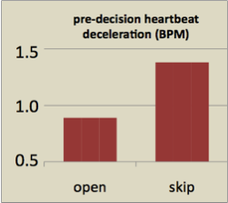

Figure 3: HR preceding the decision to open a door or to skip a door.

Relation with being intuitive
The HIP questionnaire results in two measures ‘ratio’ and ‘intuition’. None of these scores correlated with the amount of learning in the doors-task.

Psi results

Presentiment
Heart rate is indeed slower preceding a -100 punishment than preceding a +100 reward (figure 4). (t(37) = 1.90, p= .03 (one-tailed))

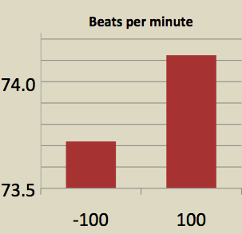

Figure 4: Presentiment: Heart Rate preceding random losses are slower than preceding win’s

Relation with being intuitive

The HIP intuition measures did (not significantly) negatively correlate with the psi measure.

Discussion
The Doors-Experiment shows that it is possible to simultaneously do research that addresses main stream research questions and psi related questions. In a recent conference on intuition it was observed that main stream researchers became open-minded skeptics when confronted with this type of experiments.
A part from intuition-research there other fields where integration might be possible. The field of ‘Altered States of Consciousness’ is an obvious one. Meditation studies on psi, for example, can easily incorporate a research question on other aspects of meditation.
The field of emotion research seems also a candidate for integrative research, In fact one cannot do research on presentiment without answering also a main stream question by analyzing the responses rather than the behavior before stimulus-onset.
The conclusion is that there is potential for a global research strategy geared toward integration with main-stream. Such an approach might have two effects:
1. Estimating relative contribution of psi and other factors in human behavior.
2. Psi hypotheses will become more ordinary (thus acceptable) to mainstream psychologists

