Somatic psi: heart rate changes reflect future events, but do these changes improve our choices?
Eva Lobach¹, & Dick Bierman¹
¹University of Amsterdam, Amsterdam, The Netherlands
Abstract
We define ‘somatic psi’ as changes in physiological processes that are associated with events that are distant in time, distant in place, or distant in both. There are various types of somatic psi, such as evident from DMILS (Direct Mental Interaction with Living Systems) studies, where someone may bring about changes in the physiological processes of someone else in a different room, or presentiment, where unpredictable, often emotionally charged future events are associated with physiological changes in people who sit passively in a chair. The present study focuses on somatic psi in a decision making context.
Participants (n=36) with and without yoga/meditation experience guessed which one of two sequentially presented pictures would later turn out to be the target, while heart rate was being registered continuously. The study aimed to explore whether any heart rate changes for targets and non-targets would be used in the actual decision making process and looked for mediating factors. Included were gender, yoga and meditation experience, interoception (sensitivity to bodily processes) as measured with a heartbeat detection task, absorption (Absorption scale, Tellegen & Atkinson, 1974) and intuition (HIP questionnaire, Taggart & Valenzi, 1990).
Results replicated those earlier reported by Tressoldi, Martinelli, Massaccesi, and Sartori (2005), showing that heart rate was increased while looking at the picture that would later be shown to be the target. Results suggested that especially for women these heart rate changes correlated with correct choices, but there was no evidence that these differences were actually used in their conscious choices. Although participants with more yoga and meditation experience did not have more hits, they showed marginally larger heart rate differences between target and non-target pictures. This study found no relation between performance on heartbeat detection task, absorption scale, or intuition questionnaire on the one hand, with number of hits, heart rate differences between targets and non-targets or yoga and meditation experience on the other.
A potentially promising theoretical approach is Bierman’s Consciousness Induced Restoration of Time-Symmetry (CIRTS), which assumes that especially so-called ‘coherent’ states of consciousness may create circumstances that allow time-symmetry of physical processes (Bierman, 2008). EEGs of advanced meditators have shown sustained synchronous firing, which may be an indication of the type of coherence that is proposed by CIRTS. Future research should further explore the relationship between different types of meditative states, EEG synchrony and various forms of somatic psi.

Correspondence to e.lobach@uva.nl

Introduction

Subtle changes in physiological processes, such as skin conductance, pupil size, and heart rate, appear to be involved in the decision making process (e.g., Damasio & Bechara, 1997, Einhäuser, 2010, Lobach & Bierman, 2007). These changes are generally thought to be either caused by unconscious memories of past events, triggered by the presented stimuli, or by physiological changes inherent in making a decision. There is some experimental evidence, however, that future events may affect physiological processes during decision making as well (e.g., Don, McDonough, & Warren, 1998; Tressoldi, Martinelli, Massaccesi, & Sartori, 2005). For instance, participants in such a study looked at four sequentially presented pictures while their heart rate was being registered (Tressoldi et al., 2005). After each sequence of four pictures they had to guess which one would later be picked by the computer as the target. Heart rate was shown to be increased for the picture that would later be the target. Nevertheless, conscious choices were at chance level, and there was no indication that those subtle changes in heart rate informed the choices.
The present study attempts to replicate Tressoldi et al.’s finding with a slightly altered set-up. First, we reduced the task to two pictures instead of four; this would double the average percentage of hits and make the task more rewarding for the participants. Second, we reduced the duration of the presentation of each of the two pictures from ten seconds to three. The raw data of Tressoldi et al. (2005) showed that effects for target vs. non-target appeared to be limited to the first two seconds of the stimulus presentation, so a longer presentation of the pictures did not seem to be necessary. Third, we increased the number of trials from 20 in the original Tressoldi et al. experiment to 48, to enhance statistical power.
For this somatic psi experiment we expected to replicate Tressoldi et al.’s findings that pre-choice heart rate would be higher while participants looked at the picture that would later be the target.
In addition, we explored whether any heart rate difference were related to the actual choices that participants made: Would those heart rate differences affect their subsequent choices and help people to correctly identify the future target picture?
Furthermore, we looked for factors that might be associated with this type of somatic psi. The variables we took into consideration were:
- Gender differences: Women are thought to be more ‘intuitive’, which is sometimes corroborated by experimental evidence. We were not sure what to expect. Women could show a more pronounced pre-choice heart rate difference between targets and non targets, make a better use of this difference, or both;
- Yoga/meditation experience. Although there are different types of yoga, and different types of meditation, all seem to claim that longer and more intense practice will enhance intuition and increase a sensitivity to bodily processes. An increased sensitivity to heart rate changes would allow for a more effective use of any pre-choice heart rate differences between target and non-target. We expected that more yoga/meditation experience might thus be associated with that more effective use, potentially leading to a higher percentages of hits;
- Interoception. Interoception is the awareness of bodily processes. A measure of interoception would help us to explore whether increased interoception is a) correlated with yoga/meditation experience; and b) related to the effective use of heart rate changes in the actual choices;
- Absorption. Absorption (as measured by Tellegen’s Absorption Scale, Tellegen & Atkinson, 1974) is a trait that has shown to be related to hypnotizability. In some experiments, high levels of absorption were positively related with psi effects. We expected participants scoring high on absorption to have a higher percentage of hits;
- Intuition. For exploratory reasons we also included the Human Information Processing (HIP questionnaire (Taggart & Valenzi, 1990), which aims to measure intuition, and may tap personality variables that are related to the effective use of physiological changes in decision making.

Method
Participants
Forty participants (24 female) participated. They were recruited among students and teachers of yoga and meditation, and among friends of the experimenters.
Due to a large number of outliers (> 15) in the heart rate signal, the data of four participants were excluded from the analyses. The final number of participants was thus 36 (21 female), the average age was 35.8 years (sd 13.4).
Yoga/meditation experience was non-existent or negligible for 21 participants. For the others (15 participants), experience varied from one year, once a week, to more than 25 years, several times a week. For purposes of analyses, we decided to compare only those 9 participants who have been practising yoga and/or meditation for more than three years with a minimum of once a week with all others.

Materials
Computer task. The somatic psi computer task presented stimuli with the software package Presentation (Presentation Version 14.1, Neurobehavioral Systems, Inc.). Two pictures were randomly picked (without replacement) from a pool of 96 neutral stimuli showing nature scenes of flowers and leaves. The target was determined directly before the start of the trial by using the randomization feature in the Presentation software. The two pictures were presented individually for three seconds each. Then both appeared simultaneously for a maximum of three seconds while the participant guessed which one would be the target, after which the target picture was shown. (Fig. 1)


0 3000 ms | | 3000 ms | |Choice < 3000 ms | | Feedback 2000 ms
Figure 1 Trial sequence. Two pictures are presented one at a time for 3 seconds each. Then both are presented simultaneously and the participants chooses within 3 seconds which one is the target. Feedback shows which picture was the actual target for 2 seconds, while a pleasant or unpleasant sound indicates a hit or incorrect choice respectively.

A correct choice was accompanied by a pleasant sound, an incorrect choice by an unpleasant sound. The percentage of correct choices was indicated on the screen and updated with each trial.

Heart rate measurement and data processing. Heart rate was measured with 512 samples/s using four Biosemi active electrodes and Biosemi Active AD-Box with Actiview software. Two electrodes were attached to the earlobes, a third was placed directly left of the chest bone, and the fourth on the right side, directly under the lower rib. To synchronize participants' behavior in the computer task and heart rate, Actiview software receives markers from the Presentation computer task, indicating for each trial the start of the first and the second picture, whether it is the target picture, which picture is selected by the participant, and start of feedback.
Afterwards, R-peaks of the heart signal were identified and marked using Brain Vision Analyzer software (BVA) after which both R-peak markers and computer task markers are combined in one file. The intervals between R-peaks are inter beat intervals (IBIs). These intervals were normalized (dividing each heartbeat interval by the average inter beat interval for that participant), in order to correct for individual differences in heart rate, and then interpolated to allow for the fact that stimulus onset did not coincide with heartbeats. Mean inter beat intervals for target and non-target pictures were calculated separately for hits and misses. For the duration of each picture three inter beat intervals were calculated.

Interoception measurement. Heartbeat detection was taken as a measure of interoceptive ability. The task was designed after the description in Pollatos (2009). The participants silently count their own heartbeats during three separate intervals of 25, 35, and 45 s duration. They receive on-screen instructions, but no information is given about either the length of the counting intervals, nor their performance. Both a sound and a sign on the screen indicate when they need to start and stop counting. After each interval, they enter the number of counted heartbeats into the computer. Interoceptive awareness was determined by calculating a heartbeat perception score:
,
where R stands for the number of recorded heartbeats, and C stands for the number of counted heartbeats. The heartbeat perception score can thus vary between 0 and 1 with high scores indicating only small differences between counted and recorded heartbeats.

Absorption Scale. The Tellegen Absorption Scale (Tellegen & Atkinson, 1974) consists of 34 statements, of which participants have to indicate whether or not that statement applies to themselves. An example of a statement is: “Sometimes I feel as if my mind could envelop the whole world.”

HIP Questionnaire. The Human Information Processing Questionnaire (Taggart & Valenzi, 1990) consists of 30 items, distributed over 3 intuition and 3 ratio scales of 5 items each. Participant indicate the applicability to themselves on a scale from 0 (not applicable at all) to 6 (completely applicable). An example of an Intuition statement is: “I like to find new and better ways of doing things”.

Procedure
The somatic psi experiment was the first task in a session that included four experimental tasks in total. At the beginning of the session, participants received general information about the procedure, after which they signed a consent form.
They were escorted to the adjacent room, where they were seated in front of a computer and the four electrodes were attached. The experimenter made sure the participant was comfortable and the heart signal was correctly saved. The somatic psi choice task was then started, which lasted for approximately 15 minutes, followed by an unrelated task lasting about 10 minutes. The next task was the heartbeat detection task (3 minutes), after which the participant was offered a short break and something to eat or drink. After the break the participant received the Absorption Scale on paper, and was shown how to fill in the HIP questionnaire on the computer. The two questionnaires took about 10 minutes to complete. The session continued for approximately another half hour with two additional tasks.

Results

Overall hitrates (“Conscious psi”). Averge number of hits (out of 48 trials) was 23.4 (sd 3.3), as would be expected by chance. Men (24.2 (sd 3.0)) scored non-significantly higher (22.9 (sd 3.5)) than women, t = 1.24, n.s.

Target/non-target difference and subsequent choices. Normalized and interpolated interbeat intervals for target and non-target pictures and for hits and incorrect choices were subjected to a
2 (target and non-target picture) * 2 (hit and incorrect choice) * 3 (interbeat interval 1, 2 and 3) repeated measures ANOVA. The results showed a significant effect for target in the expected direction (F(1,35) = 4.18, p < .05, partial η²= 0.11). As can be seen in Fig 2, the interbeat intervals decrease while looking at the picture that would later be the target. Smaller interbeat intervals mean that the heart rate goes up, supporting the finding by Tressoldi et al. (2005).

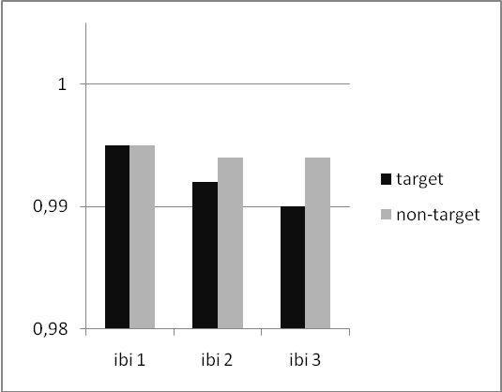

Figure 2. N = 36. Three normalized interbeat intervals (IBI) during presentation of target and non-target pictures. During the presentation of the stimulus IBIs become smaller (indicating an accelerated heartbeat) while looking at the picture that would later turn out to be the target.

The same repeated measures ANOVA showed a marginally significant three-way interaction of picture (target or non-target) by choice (hit or miss) by interbeat interval (IBI1, IBI2, IBI3), F(2,70) = 3.02, p = .055, partial η² = 0.08. As can be seen in Figure 3, heartbeat intervals decrease (indicating an accelerating heart rate) for the target and increase (indicating a decelerating heart rate) for the non-target when the participant correctly chooses the target and scores a hit (panel a), while heartbeat intervals decrease for both target and non-target alike when the participant chooses the non-target (miss, panel b). This means that if heart rate slows down while the participant looks at the non-target, the participant appears to be more likely to choose the target picture.

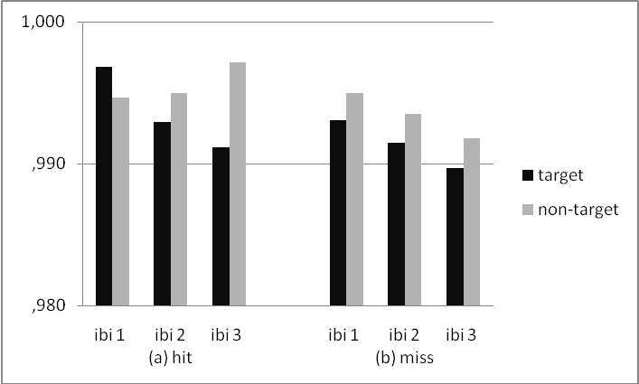

Figure 3. N=36. Three-way interaction of Picture by Choice by IBI, indicating that for trials where participants correctly identify the target (scoring a hit) heart rate slows down during presentation of the non-target, and accelerates during presentation of the target (panel a), while there is no such diverging heart rate effect for target vs. non-target in the trials that resulted in misses (panel b)

Gender differences. When conducting the same 2 (target and non-target picture) * 2 (hit and incorrect choice) * 3 (interbeat interval 1, 2 and 3) repeated measures ANOVA for men and women separately, a somewhat different picture emerged.
For the men, a marginally significant main effect for picture (target or non-target, F(1,14) = 3.94, p = .07, partial η² = 0.23) and a significant interaction of picture and interbeat interval (F (1.25,17.5) = 4.70, p < .05, partial η²= 0.25) held up (see Fig. 4), but there was no significant three-way interaction.

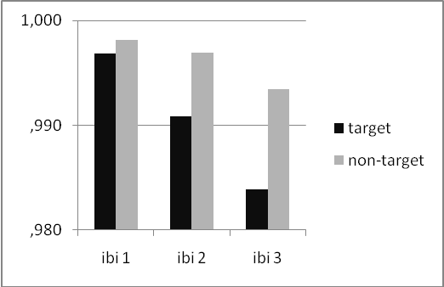

Figure 4. Main effect of Picture, and interaction effect of Picture by IBI for men (n=15). Heart rate accelerates (inter beat intervals decrease over ibi 1 through ibi 3) while looking at the picture that would later turn out to be the target.

For the women, a main effect for picture (F (1,20) = 1.12, n.s.) was obscured by the (marginally) significant three-way interaction effect of picture (target or non-target) by choice (hit or miss) by interbeat interval (F(1.19,23.78) = 3.53, p = .07, partial η²= 0.15) (Fig.5), again indicating that if heart rate decreases while looking at the non-target, it is more likely that the target picture is chosen.
This means that the earlier three-way interaction effect can mainly be attributed to the women.

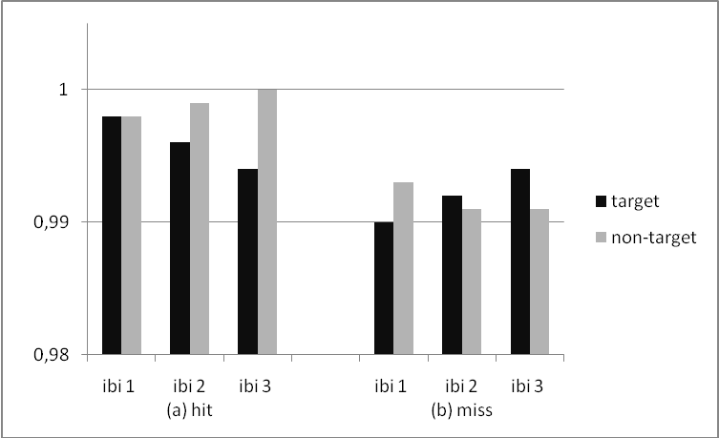
Figure 5 Three-way interaction effect of Picture by Choice by Ibi for women (n=21). (a) Correctly identifying the target (scoring a hit) is associated with a slowing down of heart rate during presentation of the non-target. (b) A slightly reversed pattern appears in trials where women make an incorrect choice, resulting in a miss.

Heart rate differences and conscious choices. In order to see whether the suggestive divergence for heart rate for trials with hits vs. trials with misses means that those participants that show a higher heart rate divergence act on these heart rate changes and thus achieve more hits as a measure of conscious psi, those differences between target and non-target were correlated with the total number of hits. The correlation turned out to be non-significant (p > .30) when analysed across all participants, for women and men separately (ps > .18), and when controlling for heartbeat detection score (measure of interoception, sensitivity to bodily processes) (ps > .23).

Yoga/meditation experience. Participants with yoga and meditation experience did not guess the targets correctly more often. However, their heart rate showed a more pronounced difference between target and non-target pictures, although the difference with participants without yoga/meditation experience was only marginally significant, t(35) = -1.60, p =.06 (one-tailed) (Fig 6, panel (a)). Interestingly, when looking at hits and misses separately, the heartrate difference for targets and non-targets in trials with hits were again more pronounced (though statistically marginally significant) for participants with yoga/meditation experience (t(35)= -1.54, p = .07 (one-tailed)), while for trials with misses the two groups did not differ statistically (Fig 6, panel (b)).
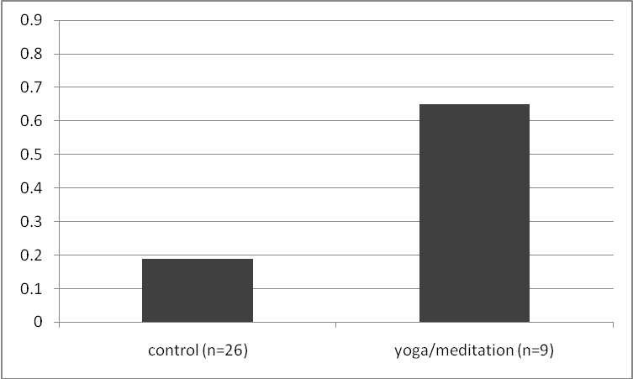
(a)

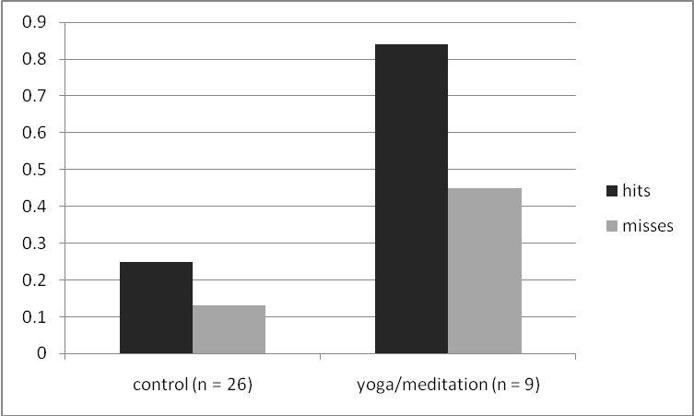
(b)
Figure 6. Heart rate difference (in tenths of %) for target and non-target pictures. (a) Heart rate difference are more pronounced for participants with yoga/meditation experience than for participants without yoga/meditation experience (control). (b) Heart rate differences between target en non-target pictures in trials with correct guesses (hit) were on average larger than for trials with incorrect guesses (misses), but especially for participants with yoga/meditation experience.

Heartbeat detection Task, Absorption Scale, HIP
Doing well on the heartbeat detection task (a measure of interoception) was not related to scoring more hits with the computer task, or with heart rate differences between targets and non-targets. Similarly, scores on the Absorption Scale and the HIP intuition scales were not associated with the number of hits, or with heart rate differences either.

Discussion

Based on the results of this study and others like it, we conclude that future events coincide with heart rate changes in the present, a form of “somatic psi”. The results nicely replicate earlier findings by Tressoldi et al. (2005), showing that heart rate accelerates (interbeat intervals decrease) when looking at pictures that will later turn out to be targets.
This effect could have been due to a naturally enhanced heart rate response to the first stimulus in a sequence, if by chance a disproportionate number of targets would have been the first stimulus. However, there was no significant difference (t(35) < 1) between the average number of times the target was presented first (23.5, sd 3.9) or second (24.5, sd 3.9), so this alternative explanation does not seem to pertain to these results.
Although our results thus support the idea that future events are positively related to heart rate changes in the present, the story becomes more complicated when we explore whether this apparent information about the future is being used to improve our choices. It turns out that especially for women, divergent heart rates for targets and non-targets appear to be connected to subsequent correct choices, suggesting that women indeed let their choices be determined by how their heart rates reflect future events. However, these heart rate changes did not actually result in above chance percentages of hits, even when taking into account that a higher sensitivity to bodily processes (interoception) may be required to make use of those divergent heart rates.
Perhaps this is all for the best, as otherwise it would lead us into unsolvable paradoxes; were we able to act on heart rate changes that correlate with future events, then those future events could not serve as the alleged sources of somatic psi.
The complicated three-way interaction between heart rate changes and hits and misses that was especially pronounced in women may perhaps be confounded by a non-psi effect, namely the ‘somatic choice’ effect. In earlier experiments conducted by others (e.g., Einhäuser et al. 2010) and by ourselves (Lobach & Bierman, 2007; Lobach, 2010), physiological processes were shown to indicate which stimulus the participant decided to choose. As can be seen in Figure 5, the divergent heart rate changes for target and non-targets in trials with hits, are more or less mirrored by a complementary divergence for trials with misses. Indeed, when comparing heart rate changes for chosen and non-chosen pictures, relative heart rate acceleration was shown to be significantly associated with choosing that picture as target, while relative heart rate deceleration was associated with not choosing that picture as target, in line with our earlier findings. The interaction effect of heart rate changes and hits may thus at least in part be attributable to the somatic choice effect, which could perhaps by chance have been somewhat more pronounced in trials that resulted in hits.

It appears that participants with yoga and meditation experience showed somewhat stronger target/non-target heart rate differences. Although the effects were small and only marginally significant, they were in the expected direction, and they confirm earlier but scarce empirical evidence that suggests that yoga and/or meditation practice increases somatic sensitivity to future events (Bierman, 2007; McCraty, Atkinson, & Bradley, 2004). However, if this is indeed the case, this sensitivity appears to be entirely unconscious and ineffectual in decision making; again there was no convincing evidence that the more pronounced heart rate effects for participants with yoga/meditation experience were related to better choices (resulting in more correct guesses of the target picture).
This study found no evidence that interoception, as measured with a heartbeat detection task, absorption (Tellegen & Atkinson, 1974) or intuition (HIP, Taggart & Valenzi, 1990) were associated with this type of somatic psi.

All in all these results indicate again that somatic processes appear to be intimately connected to future events, but there is no evidence so far that we can use this connection to our advantage in order to improve our choices. The findings with yoga and meditation experience are intriguing, and merit more studies, as the sample size in the present study was rather small. Also, there are different types of yoga and different types of meditation. Although representatives of all different types usually claim that regular practice will improve sensitivity and intuition (giving us reasons to put these different types together indiscriminately in this study), those claims may not be equally true for all types of yoga or meditation.
Any variables that co-vary with psi-effects, such as yoga and meditation experience appears to do, may offer clues to the mechanisms involved in somatic psi. An interesting take on this is offered by Bierman (2008), who argued that the theoretically plausible but in practice apparently non-existent time symmetry of many natural processes in physics may be restored and measurable under specific circumstances. One of these circumstances would be when consciousness is part of the physical system(especially during more so-called ‘coherent’ states of consciousness), hence the name of this approach, ´Consciousness-Induced Restoration of Time-Symmetry’ (CIRTS). There is indeed evidence that more coherent states may be associated with meditation. EEGs of advanced meditators show more sustained phase-synchrony, especially in meditative states (e.g., Lutz, Greischar, Rawlings, Ricard, & Davidson, 2004), presumably associated with a more coherent state of consciousness. Obviously, much is still unknown, but considering that in many countries, more and more people practise yoga and meditation, it will in the future only become easier to include advanced practitioners in studies that aim to disclose the pertinent factors in somatic psi.

References

Bechara, A., Damasio, H., Tranel, D., & Damasio, A. R. (1997). Deciding advantageously before knowing the advantageous strategy. Science, 275, 1293-1295.
Bierman, D. (2007). fMRI and photo emission study of presentiment: The role of 'coherence' in retrocausal processes. Unpublished Bial report .
Bierman, D.J. (2008). Consciousness induced restoration of time-symmetry. A psychophysical theoretical perspective. Conference proceedings of the 51st Convention of the Parapsychological Association. Winchester, UK.
Don, N. S., McDonough, B. E., & Warren, C. A. (1998). Event-related brain potential (ERP) indicators of unconscious psi: A replication using subjects unselected for psi. The Journal of Parapsychology, 62, June, pp. 127-145.
Einhäuser, W., Koch, C., & Carter, O. (2010). Pupil dilation betrays the timing of decisions. Frontiers in human neuroscience, 4, article 18, 1-9.
Lobach, E., and Bierman, D.J. (2007) Exploring the role of the heart during an intuitive decision making task. Poster presented at the Biannual conference of Psychonomics, December 2007, Egmond aan Zee, The Netherlands, December 2007
Lobach, E. (2010). Somatic components of Intuition and Psi. 8th Symposium “Behind and Beyond the Brain” . Proceedings of presented papers. In press.
Lutz, A., Greischar, L.L., Rawlings, N.B., Ricard, M., & Davidson, R.J. (2004). Long-term meditators self-induce high-amplitude gamma synchrony during mental practice. PNAS 101, 46, 16369–16373.
McCraty, R., Atkinson, M., & Bradley, R. (2004). Electrophysiological evidence of intuition: Part2. A system-wide process? The Journal of Alternative and Complementary Medicine , 325-336.
Pollatos, O., Traut-Mattausch, E., & Shandri, R. (2009). Differential effects of anxiety and depression on interoceptive accuracy. Depression and Anxiety, 26, 167–173.
Taggart, W. & Valenzi, E. (1990). Assessing rational and intuitive styles: a human information processing metaphor. Journal of Management Studies, 27, 149–72.
Tellegen. A. & Atkinson. G.. (1974). Openness to absorbing and self-altering experiences (“absorption”). A trait related to hypnotic susceptibility. Journal of Abnormal Psychology 83, 268–277.
Tellegen, A. (1992). Note on the structure and meaning of the MPQ Absorption Scale. Unpublished manuscript, University of Minnesota.
Tressoldi, P.E., Martinelli, M., Massaccesi, S., & Sartori, L. (2005). Heart rate differences
between targets and nontargets in intuitive tasks. Human Physiology, 31, 6, pp. 646-650.

Presentation documentation with Presentation Version 14.1 describes the randomization as follows: “The Presentation random number generator is based on the ran1 algorithm described in Section 7.1 of the book "Numerical Recipes in C". The "Minimal Standard" generator used by Presentation for this algorithm is actually the rand() function of the C Standard Library.”
Degrees of freedom are Greenhouse-Geisser-corrected because of a statistically significant departure of sphericity
This possibility was kindly brought to my attention by Tim Schönwetter.

