Anomalous Anticipatory brain activation preceding exposure of emotional and neutral pictures

Dick J. Bierman and H. Steven Scholte

University of Amsterdam, Roetersstraat 15, 1018 WB Amsterdam, Netherlands

Abstract
The present study examined the neural substrates of anticipation in conjunction with functional magnetic resonance imaging (fMRI). Ten subjects were scanned while 48 pictures were presented. Each stimulus sequence started with the 4.2 seconds presentation of a fixation point before and during which the anticipation was measured. After the exposure of the stimulus picture which lasted also 4.2 second there was a period of 8.4 seconds during which the subject was supposed to recover from the stimulus presentation.
It is found that large parts of the visual cortex do show larger activity after emotional stimuli than after calm. All brain regions that show a difference have also a response on calms except for regions that are at or near the amygdala. Here violent and erotic stimuli do generate a response but the response on calm stimuli is flat.
Anticipatory effects tend to influence baseline values and hence influence the response values. This might be a problem if the subject is guessing the upcoming stimulus condition correctly but with proper randomization this is theoretically impossible. Great care was taken to randomize stimulus conditions with replacement while using different pictures for each stimulus presentation .
Results suggest that, in spite of proper randomization, anticipatory activation preceding emotional stimuli is larger than the anticipatory activation preceding neutral stimuli. For the male subjects this appeared before the erotic stimuli while for the female both erotic and violent stimuli produced this anomalous effect. Possible normal explanations of this apparent anomaly, also called ‘presentiment’, are discussed. Most notably the possibility that this effect is just a result of ‘fishing’ for the right analysis out of many possible analyses. Exploratory results are presented dealing with differential effects in the responses to emotional stimuli and calm visual stimuli.

1. Introduction
Anomalous anticipatory effects in skin conductance measurement have been observed in studies with randomized presentation of emotional and neutral stimuli (Radin 1996, Bierman & Radin 1998, 2000). The anomaly consists therein that the anticipatory physiological signal is larger for subsequent emotional stimuli than for subsequent neutral stimuli. These stimuli were randomized with replacement so that each trial is completely independent of the previous ones and the subject has no way to ‘foresee’ what the future stimulus will be. These experiments follow in principle a simple paradigm, one that is often used in research on the psychophysiological effect of emotional material (see fig1).

Fig. 1 Timing of stimulus. Baseline measurement occurs during first blank screen and shows anomalous anticipatory effect.

First a fixation point (or a blank screen) is presented for a period of about 7.5 seconds. Then a stimulus is randomly selected and presented for about 3 seconds, which is followed by a period during which the physiology return to baseline. This period is generally in the range of 10 or more seconds. During each trial a continuous physiological record is measured. After averaging of the signals split for stimulus condition, and while clamping the baselines at -7.5 seconds to the same value. It was found that the signals for the emotional and neutral condition not only differed after stimulus presentation but already started to differ in the period BEFORE the stimulus (fig.2)

Fig.2 Example of anomalous anticipatory differences. A larger anticipation arises before the erotic stimuli in spite of randomized presentation. These data are from a re-analysis of data published earlier by Globisch et al in Psychophysiology, 36, pp. 66-75.

In principle this anomalous effect, if real, must also be present in main stream psychophysiological emotion research. However this will generally not be noticed because baselines are measured at or just before stimulus presentation so that clamping at that point will obscure the effect and often the earlier data are even not measured. However, two main stream studies were found which had a long enough period of measurement before the stimulus, used strong emotional stimuli randomly mixed with calm stimuli, and for which the raw data could be used in a re-analysis searching for this anomalous effect. The first study concerned the well known gambling studies by the Damasio group (Bechara et al, 1996), the other concerned a study into the speed with which fear arises in animal phobics (Globish et al , 1991; see fig. 2). Both studies did indeed show the effect (Bierman, 2000). In these studies the randomization was without replacement. If randomization is not with replacement the theoretical possibility exists that in interaction with a strategy of the subject the effect can be explained. A comparison of erotic and violent material in the earlier studies suggested that there might be different time courses for these different types of emotions. However it is not possible to discriminate between different types of emotions using simple psychophysiological dependent variables (with the exception of EMG from the facial muscles).
Such a discrimination might be possible if we could measure the underlying brain processes directly which led us to do a conceptual replication using functional MRI brain imaging.

2. Method
2.1 Subjects
Ten subjects (6 male, 4 female) with a mean age of 27.2 years (sd=10.9) volunteered to participate . The study was approved by the local ethics committee and informed written consent was obtained prior to the study.

2.2 Stimulus material and presentation
The subjects were instructed to relax while passively looking via a mirror at the pictures that were presented by a computer connected to a video projector onto a screen. They were requested to try to forget any emotional material right after exposure finished so that the next presentation would be influenced as little as possible by the previous one.
The stimulus material consisted of a picture pool of 36 emotional (18 erotic, 18 violent) and 48 neutral stimuli. The neutral and violent stimuli were from the International Affective Picture System (IAPS) while the erotic material was used before in a study on sexuality (Laan et al, 1994). For each stimulus presentation the stimulus condition was determined randomly with an a priori chance 0.667 for neutral and 0.333 for emotional. After the stimulus condition was determined the pool was shuffled and the first picture of that condition was selected.
Each stimulus sequence started with the 4.2 seconds (2 volumes) presentation of a fixation point during which the anticipation was measured. After the exposure of the stimulus picture which lasted also 4.2 second there was a period of 8.4 seconds during which the subject was supposed to recover from the stimulus presentation.

2.3 MRI scanning procedure
A 1.5 Tesla Siemens system was used to acquire T1 weighted high resolution structural images and echo-planar T2* weighted images with BOLD (Blood oxygenation level dependent) contrast. Functional images were acquired by continuous scanning a total of 8 volumes per stimulus sequence for a total of 384 volumes. Each volume consisted of 21 slices. The field of view was 200 mm with 64² matrix (3.1 mm²) in plane resolution and a slice thickness of 5 mm. Each run began with 3 dummy volumes to allow T1 saturation effects to disappear; these volumes were subsequently disregarded.
Each subject got first a MPRAGE high resolution scan lasting about 20 minutes. Subsequently the subject got the task instruction outside of the scanner and after a position localizer scan of about 2 minutes the task of about 13 minutes was presented. For a few subjects further tasks followed.

2.4 Data Analysis
Data were analyzed using Brainvoyager 2000 (V4.6). Scans were aligned using the first volume as a reference and after slice time correction were transformed for each subject into Talairach space. Fitting of the BOLD was done using a semi hemodynamic response curve with a duration of 8.4 seconds.
Preprocessing of the data was limited to linear trend removal and spatial smoothing (8 mm FWHM.) The primary step in the analysis was the fitting of the data to a general linear model with 6 predictors. These predictors corresponded to the following events: 8.4 seconds before the stimulus (before neutral, erotic and violent stimuli) and the appearance of these three types of stimuli themselves. The second step was then to select and display the brain region ‘B’ for which the signals were significantly explained by the predictors neutral stimulus, erotic stimulus and violent stimulus. (Brain) Regions of Interests (ROI) were then selected from the brain region ‘B’ found in the previous step. Average BOLD signals preceding, during and following the stimulus in the main regions of interest were calculated clamping the baseline between –8 and -6 second. The main hypothesis, concerning an anomalous pre-stimulus difference in BOLD signal, was tested using the mean BOLD signals over 8.4 seconds before the stimulus for the three type of stimuli.

3. Results
a. Single subject exploration
To get some feeling for the data the first author explored the data obtained from his own participation in the experiment. Mean BOLD activity was plotted for a number of regions of interest for which the signals could be explained significantly (after multiple analysis correction) by the three stimulus related predictors. An example of the outcome of such exploration is given in fig. 3.

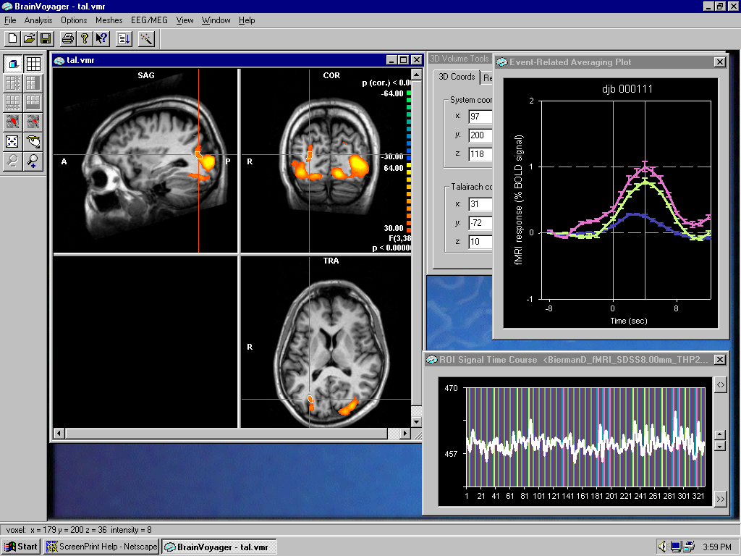

Fig. 3 Screendump of brainmap (upper left), the selected region of interest (ROI) is at the crosshairs and the mean BOLD signal in that region from –8 to +12 seconds with respect to either neutral or emotional stimulus. Stimulus presentations starts at t=0 (upper right). The pane right under gives the signal over the course of the whole experiment in that brain region.

This region was at Talairach coordinates: -31, -72, 10 and contained 670 voxels. From the plot it is clear that there is an anticipatory signal for the erotic (upper curve) stimuli but none for the violent (violet) and neutral (blue, lower) curve (t_{d}(ero vs neu) = +2.89, df=39, p<0.01 at 3 seconds before the stimulus). The difference between the means of erotic and neutral anticipation at –3 seconds is 0.203%. It should be stressed that this is a typical result and not due to a long search for a region that would show this result. Nonetheless in some regions the results were qualitatively different. In order to illustrate this qualitative difference three plots of mean bold signals are given for more or less adjacent brain regions (fig. 4 a, b, c).

(a)
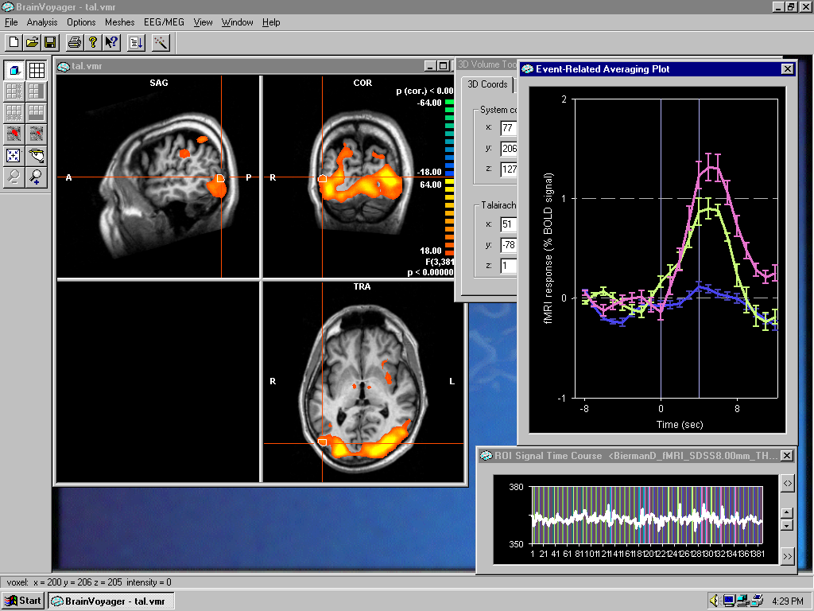 (b) 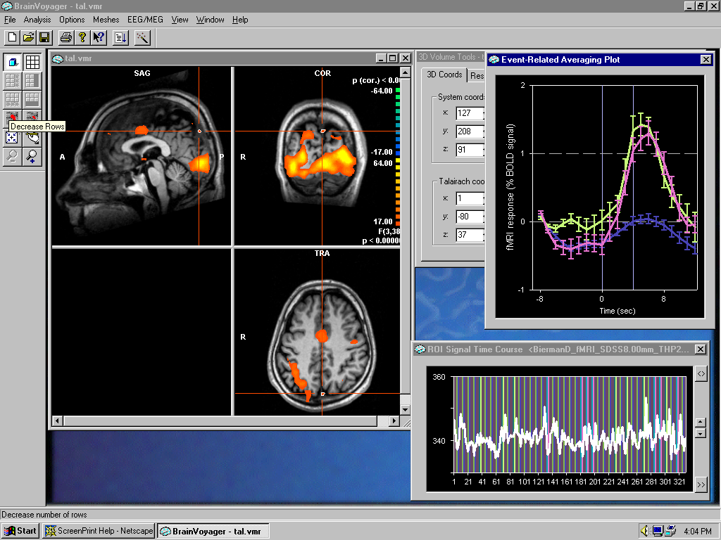 (c)

Fig 4 a,b.c Showing a shift of main anticipatory signal from erotic to violent from Talairach coordinates: a: -30,-68,37 b: -51,-78,1 and c: -1, -80, 37

It can be seen that within a relatively short distance within the brain the major anticipatory signal shift from erotic to violent. Note also that in Fig 4 b, the anticipatory bump preceding violent pictures appears earlier than the erotic anticipation and that in fig.4c only the violent anticipation is present (diff(vio vs neu) = 0.42%, t_{d}(vio vs neu) = +2.36, df=39, p<0.01 at 4 seconds before the stimulus; nr. of voxels in ROI = 56). None of the inspected brain regions had an anticipatory signal showing a definite bump before the neutral stimulus. Also increasing the maximum cluster size of the brain region of interest with factor 100 results in about 50% of the visual cortex to become a region of interest. For this whole region together the t-value becomes larger than 4.

b. Multi subjects

Exploratory stimulus related results
Figure 5 shows a cross section through the brain which indicates regions where the general linear model with 6 predictors gives a multiple analysis (Bonferoni) corrected significant fit for all subjects pooled.

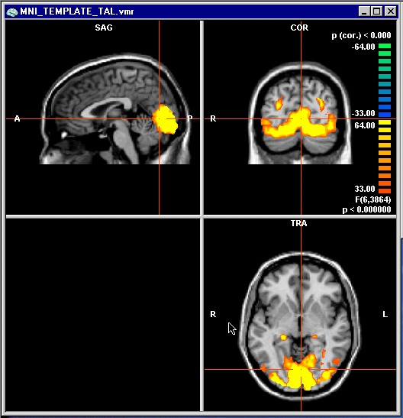
Fig.5 Fit with GLM, all subjects

The whole visual cortex is involved, which is to be expected because visual stimuli are used. In the next figure 6 the results of the contrast between emotional and neutral stimuli is given.

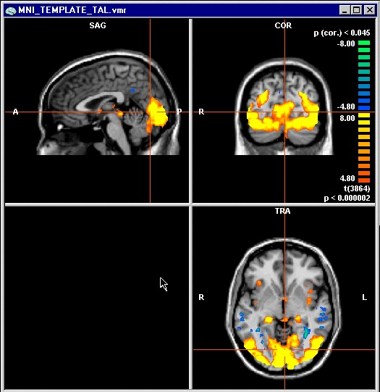
Fig.6 Contrast between emotional and neutral stimuli

Several regions of interest appear most notably in the visual cortex. A review of these regions with the associated statistics is given in appendix 1. That the primary visual cortex shows differences between stimuli types is caused by the fact that top down processing of stimuli can not be discriminated from bottom up because of the poor time resolution of the fMRI technique. Similar results have been reported by other groups using emotional and neutral visual stimuli (Lang et al, 1998). Interestingly all the regions of interest resulting from this contrast analysis do typically show a response for all stimuli also the calm pictures (e.g. figure 3 and 4) . However one region is different in this respect. This region is at Talairach coordinates (-18, -10, -4) which shows a rather flat response to calm pictures. This is a subcortical region close to or at the amygdala . Both erotic as well as violent pictures do show a response here in spite of poor fmri imaging signals for that region (Merboldt et al, 2001). The fact that erotic stimuli have impact on the BOLD from the amygdala is consistent with results from Everitt (Everitt et al, 1990) who found dramatic change in sexual behavior after lesion of the amygdala in rats. This result gives confidence in the validity of the data. (fig.7)

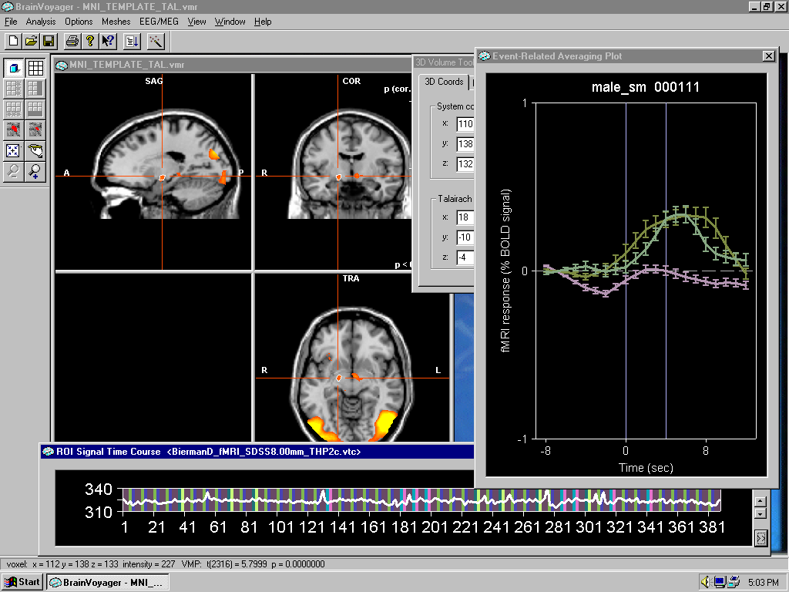
Fig 7. Average BOLD from the amygdala- region. Note that the erotic as well as the violent pictures (upper curves) give a response. There is also a significant difference in the anticipatory phase between emotional and neutral conditions.

Regions which show differential responses for erotic and violent stimuli, as well as regions where differential ‘inhibition’ occurred were also found but fall outside the scope of this paper and will be reported elsewhere.

Anticipation related results
Pooling all the subjects will increase power when similar effects occur at the same brain location. Transforming brain maps to Talairach space does correct for gross differences in brain layout but chances are that very specific effects are lost. We decided therefore to pool female and male separately because we expected that the emotional valence of our picture set might be dependent of gender. The analysis was further identical to the one sketched for the exploration of the first author’s brain map. While for separate subjects the presentiment effect was widely distributed over many brain regions, most brain regions in the pooled analyses did not show striking differences in anticipation before emotional and neutral stimuli. However there were marginally significant differences in the area around Talairach coordinates (-30, -80, 10). Fig 8a and 8b show the averages for all male and for all female with standard error for this general region. To analyze these data we imported them from the package and calculated t-values for the differences in mean BOLD values before the stimulus. This was necessary because the clamping of the data at –8 seconds is not a supported analysis in the BV package. This resulted for the female data in mean differences between the average BOLD, 4 seconds before erotic and neutral stimuli of about 0.22% (td = 1.75 df =158, p<0.05 o.t.) and before violent and neutral stimuli of 0.19% (td = 1.99, df =159, p <0.05). For the male data the results were that no difference between violent and neutral anticipation was found. The erotic anticipation however was 0.15% larger than the neutral (td = 2.10, df =226, p <0.05). The question remains how to correct these results for multiple analyses. Since the potential brain region available for testing after the fit with the general linear model is much larger than the regions selected in fig. 8 (which contains in the order of a few hundred voxels) there could have been done an estimated 100 of such tests. Thus a conservative correction would reduce the results to potentially due to chance. However it is not the case that only 1 in those 100 analyses would have produced these or similar results. For instance increasing the cluster size of the ROI with a factor of ~30 does only slightly reduce the t-value. But it reduces the number of potential analyses to less than 10.

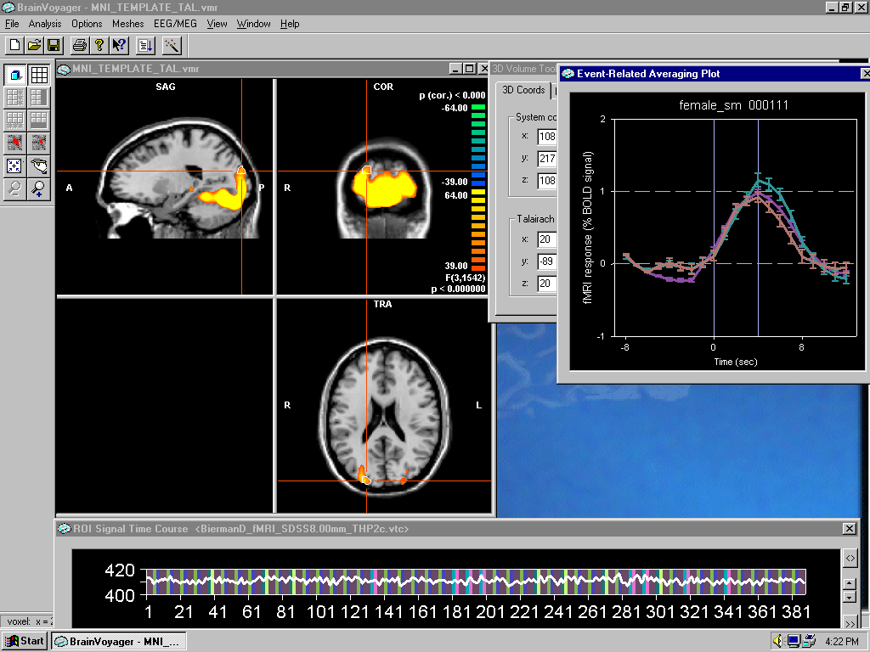
8.a
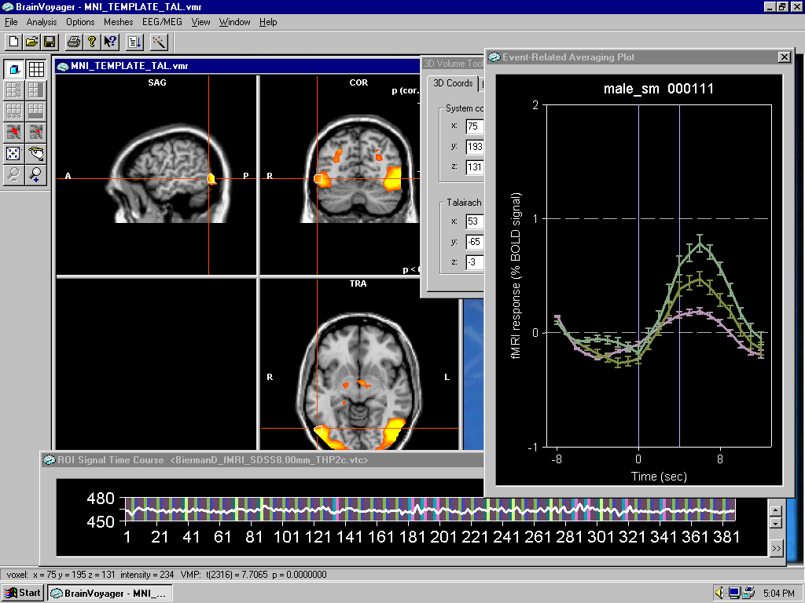
8.b
Fig 8a gives the average BOLD signal for all female subjects. An anticipatory bump is seen for both emotional stimuli while the responses do not differ much. For male (8b) there is only a bump before the erotic pictures while also the response for these pictures is the largest.

4. Discussion & Conclusion
4.1 Normal explanations of the apparent anomaly
The pooled results for male and female are statistically marginal but one has to realize that the current analyses have been done with only detrending in time in order to keep as close as possible to the raw data. Further temporal filtering will reduce error variance and hence improve the statistics. One might therefore tend to conclude that the anomalous anticipatory effects observed earlier in psycho-physiological measures like skin conductance are replicated with the BOLD as a dependent measure. This could be a significant step forward in understanding the brain processes involved in the anomaly called pre-sentiment. However before accepting the present data as a true anomaly we first have to consider possible normal explanations.

4.1.1 Randomization and Anticipation strategies
The pseudo random sequences produced by the computer algorithm were tested using the RUNS test for random sampling. Only one of the 10 sequences showed a marginal indication of non randomness (for results per subject see table 1 in appendix). Also the transition frequencies up to triplets showed no deviations form chance expectation. Recent computer simulations show however that even with a proper randomization the differential anticipation or baseline effect can occur as a consequence of a subject strategy especially for short sequences of stimuli (Dalquist et al, 2002). Therefore we did simulate the most plausible subject strategy which is based upon the gambler’s fallacy. In this the subject is expected to raise his expectation of an emotional stimulus after neutral stimulus. First by a small amount, and in subsequent neutrals with a larger amount, until this levels off due to a ceiling effect in the arousal (a sigmoid like increase function is used). This simulation is done using the ACTUAL random sequences produced in the experiment. The results show that for the whole experiment we can ‘explain’ a small difference between the anticipation preceding the emotional and the neutral pictures when subject adhere to this strategy (see table 2 in appendix). The relative effect, expressed as the difference divided by the average of the two mean anticipations, is 4% when averaged per subject and 2% when the data are first pooled before averaging. In figure 9 the mean anticipation for all subjects for both type of pictures is given after N trials. N ranges from 1 to 48, the actual number of trials in the experiment.
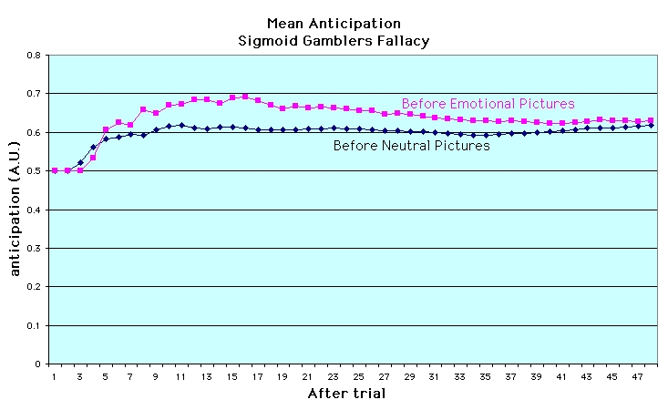

Figure 9: Mean anticipation levels for all subjects before emotional and neutral stimuli obtained in a simulation of subject’s anticipatory strategy using the actually produced random condition sequences.

This picture shows clearly that the over-all effect reduces with increasing N ending in the 2% difference. Therefore it appears that this subject anticipatory strategy cannot account for the observed results. However it should be mentioned that simulation of a linear increase rather than sigmoid increase strategy results in 4 times larger effects. As argued before this strategy is not physiologically plausible. A more convincing argument is that in our data we hardly see ANY anticipation before neutral pictures as can be seen from most figures. This contradicts any systematic anticipatory strategy. The qualitative difference between erotic and violent anticipatory BOLD as a function of gender speak also against this ‘normal’ explanation. As an illustration one could focus on the time course of the BOLD signals after erotic and non-erotic stimuli in figure 3. It can be seen that there is not a full return to baseline of the signal near the end of the erotic time courses which coincides with the anticipatory phase of the next stimulus. This is a strange and possibly even suspicious signal. Until one realizes that this specific subject happened to have two times two erotic pictures in a row and was most sensitive to erotic stimuli. In a gamblers fallacy strategy the subject should have ‘reset’ his anticipation after an erotic stimulus. He evidently didn’t do this and appeared to anticipate perfectly on the row of erotic stimuli. We therefore feel confident that the results cannot be explained away by this type of ‘normal’ explanations but further research is required to completely rule out all possible interactions between subjects anticipatory strategies and produced random sequences.

4.1.2Artefacts introduced by pre-processing.
One of the possibilities for finding differences in anticipation might be that preprocessing of the raw data causes some ‘backwards leakage’ of the difference in responses towards the anticipatory period. This is for instance possible when one uses low pass filtering. Looking at the data indeed suggests that something like this happens to some degree because some response activity can be observed in the last volume before the stimulus. This might have been introduced by the procedure of time slice correction (correcting the fact that it takes 2.1 seconds for all brain slices to be measured). However none of these filtering procedures can introduce a bump like signal. Also inspection of eye movement artefacts shows that eye movements do start at the expected time. Thus it can be concluded that the results are not due to improper preprocessing which was marginal anyway .

4.1.3 Improper hemodynamic curve
If one takes a realistic hemodynamic curve for fitting purposes the curves predicting the anticipation and the one predicting the response do overlap. In order to eliminate this we also used short lasting hemodynamic curves of 8.4 seconds. The hemodynamic curve predicting the anticipatory BOLD signal does in this approach not extend into the time domain where response differences occur. Note that also the average BOLD signals are derived directly from the ‘raw’ data and the choice of hemodynamic fitting curve is irrelevant for these average plots and the t-tests based upon these raw data. It is however relevant for the GLM fitting procedure which determines the possible regions of interest.

4.1.4 Multiple Analyses
As argued before the results of the multi subject analyses are statistically marginal and would evaporate when multiple analyses are taken into account. However a number of exploratory analyses for single subjects suggest that on the individual level the results will stand the correction against multiple analyses. For instance increasing the cluster size with a factor ~30 for the analyses done for the single subject in fig. 4 results in an increase of the t-value to 3.6 with a corresponding p-value smaller than 0.001 and a reduction of possible analyses to ~ 10 while each of these 10 possible analyses produces a significant larger BOLD preceding erotic than preceding neutral stimuli.
There is a problem though because analysis on the individual level might result in the artefact sketched in paragraph 4.1.1. We therefore feel that the current study must be seen as exploratory and should be followed up with replications using a precise procedure to allow for the selection of ROI’s on an individual level while still allowing for pooling of the data.

4.2 Relation with other brain imaging results
So far no brain imaging studies have been done directly investigating the so-called presentiment effect. However some studies measuring event related potentials in a guessing task might be interpreted as a studies investigating at least anomalous brain behavior contingent on a future event (feedback of the target) although the task is a forced choice guessing task (McDonough et al, 2002). The results indicate that the difference between the normal evoked potential and the evoked potential generated by a picture of the future feedback (target) is mainly in the form of a slow negative going wave at 150-500 msec after the test-exposure. These differences were mainly located in the right frontal cortex. These results seem not to relate to the current findings. We find the anomalous anticipatory effects mainly located in the visual cortex although this could be due to the procedure used to locate the regions of interest.

4.3 Future research
It should be stressed that this is the first time that fMRI has been used in relation to research into apparent anomalous phenomena. This type of research should ideally be performed under very stringent methodological criteria. In that respect however the current research findings should be seen as exploratory because the required methodological standards have to be developed over time.

Further analysis of the current data using random permutation statistics (Blair et al, 1993) is in progress and might reveal subtler effects for instance in cortical regions.

5. References

Bechara, A., Damasio, H., Tranel, D., Damasio, A. R. (1997). Deciding advantageously before knowing the advantageous strategy. Science, 275, 28 February 97, 1293-1295.

Bierman, D. J. & Radin, D. I. (1997). Anomalous anticipatory response on randomized future conditions. Perceptual and Motor Skills, 84, 689-690.

Blair, R. C. & Karniski, W. (1993). An alternative method for significance testing of waveform difference potentials. Psychophysiology, 30, 518-524.

Dalkvist, J., Westerlund, J. & Bierman, D.J. (2002). Simulations of expectation effect in sequential presentations of activating and calm pictures. Proceedings of the PA-2002.

Everitt, J.W., (1990). Sexual motivation: A neural and behavioral analysis of the mechanisms underlying appetitive and copulatory responses of Male rats. Neurosci. Behav. Rev., 14:217-232.

Globisch, J., Hamm, A.O., Estevez, F., and Öhman, A. (1999). Fear appears fast: Temporal course of startle reflex potentiation in animal fear subjects. Psychophysiology, 36, pp. 66-75.

Laan, E., Everaerd, W., Bellen, G. van, & Hanewald, G. (1994). Women's sexual and emotional responses to male- and female-produced erotica. Archives of Sexual Behavior, 23, 153-170.

Lang, P.J., Bradley M.M., Fitzsimmons, J.R., Cuthbert, B.N., Scott, J.D., Moulder, B. & Nangia, V. (1998). Emotional arousal and activation of the visual cortex: An fMRI analysis. Psychophysiology, 35, 199-210.

Merboldt, K.D., Fransson, P., Bruhn, H. & Frahm, J. (2001). Functional MRI of the human amygdala. NeuroImage, 4, 253-257.

McDonough, B. E., Don, N.S. & Warren, C. A. (2002). Differential event-related potentials to targets and decoys in a guessing task. To be published in: Journal for Scientific Exploration.

Morris, J.S., Ohman, A. & Dolan, R.J. (1998), Conscious and unconscious emotional learning in the human amygdala. Nature, 393, 4 June 19989. 467-470.

Radin, D. I. (1997). Unconscious perception of future emotions: An experiment in presentiment. Journal of Scientific Exploration, 11 (2), 163-180.

Appendix

Table I : Randomness test of the stimulus sequences using RUNS test

Subject | Runs | p
DB | 23 | 0.32
GB | 21 | 0.33
JJ | 23 | 0.44
KH | 29 | 0.04
dK | 24 | 0.21
DN | 17 | 0.36
AO | 13 | 0.47
PO | 18 | 0.14
IS | 25 | 0.32
WO | 21 | 0.32

Table 2: Results of simulations of sigmoid gamblers fallacy strategy per subject

 | sumanti_neutral | n_neutral | sumanti__emo | n_emo | meananti_neu | meananti_emo
DB | 19.5 | 33 | 9.7 | 15 | 0.590909091 | 0.646666667
GB | 18 | 31 | 10.4 | 17 | 0.580645161 | 0.611764706
JJ | 17.6 | 30 | 11.3 | 18 | 0.586666667 | 0.627777778
KH | 15.1 | 29 | 11.1 | 19 | 0.520689655 | 0.584210526
dK | 22.6 | 35 | 8.8 | 13 | 0.645714286 | 0.676923077
DN | 24.7 | 36 | 8.4 | 12 | 0.686111111 | 0.7
AO | 28.1 | 39 | 6.8 | 9 | 0.720512821 | 0.755555556
PO | 19.1 | 31 | 10.7 | 17 | 0.616129032 | 0.629411765
IS | 18.3 | 30 | 10.1 | 18 | 0.61 | 0.561111111
WO | 17.3 | 30 | 11.1 | 18 | 0.576666667 | 0.616666667

The standard ‘random’ call from the DOS c-library was used and seeded by clocktime at the beginning of the experiment.
A volume is the name for a complete scan of the whole brain. This scan lasts 2.1 secs and consists of a number of consecutive slices. The time resolution therefore is limited but even faster scanning cannot increase the resolution due to the inherent slow response of the BOLD signal.
Details are given for the sake of potential replication. Basically the technique measures blood oxygenation level each 2.1 seconds throughout the brain. This signal is assumed to correlate with neural activity.
Talairach space is the space of a standardized brain. The real brain fitted on this standard brain by a number of transformations.
In contrast with the neurological convention used by the BV analysis package we give the Talairach coordinates according to radiological convention.
A voxel is the smallest 3D volume from which the image is constructed (in our case 3 * 3 * 5 mm)
The hemodynamic response curve is the assumed response curve of the BOLD signal if a single event is processed. For General Linear Model fitting such a response curve is used with different weights to ‘explain’ as much of the observed signal as possible.

